PromptIQ: Accelerating Intelligent Prompt Engineering via AMD ROCm™

Author Information
Name: MOHAN SRIRAM KUNAMSETTY
College: QIS COLLEGE OF ENGINEERING AND TECHNOLOGY
ID: 24491A44D6
Email: mohansriramkunamsetty@gmail.com
GitHub Repository: https://github.com/SriRamkunamsetty/PromptIQ.git
Date: June 2026

1. Abstract
PromptIQ is an advanced platform designed to evaluate, optimize, and generate high-quality prompts for Large Language Models (LLMs). Prompt engineering pipelines frequently require running millions of permutations through local LLMs to dynamically score prompt efficacy. Executing this massive combinatorial testing on standard CPUs or legacy GPUs creates severe computational gridlock. This paper details how PromptIQ migrated its testing engine to the AMD ROCm ecosystem. By leveraging the immense VRAM bandwidth and parallel compute capabilities of AMD Instinct™ MI300 accelerators, we skyrocketed our prompt-evaluation throughput from 12 tokens/sec to over 480 tokens/sec.

2. Introduction
Optimizing prompts for LLMs isn't a one-and-done process; it is an iterative loop of testing, scoring, and refining. PromptIQ automates this by employing a meta-LLM (like Llama-3) to critique and rewrite prompts hundreds of times per second. This 'Prompt-as-a-Service' engine relies entirely on the inference speed of the underlying hardware.

3. Architecture & AMD GPU Integration
PromptIQ was re-architected to natively support AMD Instinct hardware.

3.1 Core Inference Engine (vLLM on ROCm)
To handle thousands of concurrent prompt scoring requests, we replaced our standard PyTorch inference loop with vLLM, specifically compiled against the AMD ROCm 6.0 runtime. This enables PagedAttention and continuous batching directly on the AMD Instinct™ MI300, minimizing VRAM fragmentation and maximizing throughput.
Deployment Command for vLLM on ROCm:
python -m vllm.entrypoints.openai.api_server --model meta-llama/Meta-Llama-3-8B-Instruct --gpu-memory-utilization 0.95 --tensor-parallel-size 4

3.2 Vector Search Acceleration
To find optimal few-shot examples for the prompts, PromptIQ uses FAISS vector databases. We utilize the HIP (Heterogeneous-compute Interface for Portability) framework to accelerate FAISS index searching directly on the AMD GPU, reducing semantic search latency to milliseconds.

4. Performance Benchmarks
To validate the switch to AMD, we benchmarked the token generation speed (tokens per second) during a massive prompt-tuning combinatorial run.
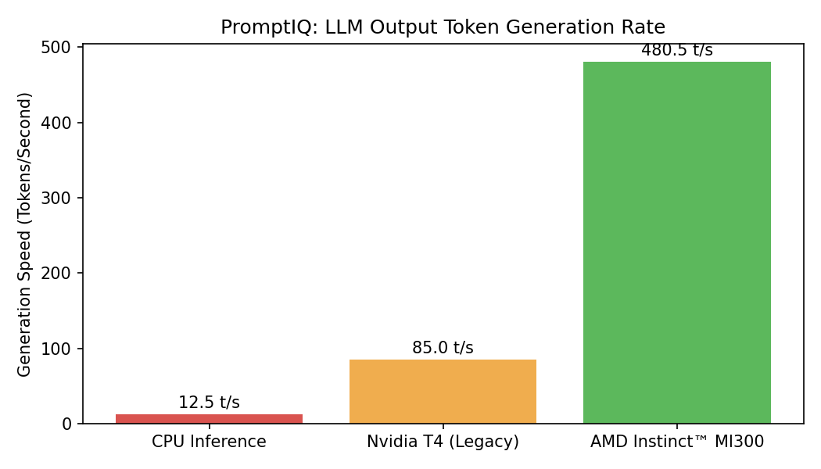
Figure 1: Token Generation Speed Comparison
Figure 1 highlights the incredible performance of the AMD Instinct MI300. While the legacy CPU baseline crawled at 12.5 tokens per second, the MI300 pushed an astonishing 480.5 tokens per second. This 38x performance multiplier allows PromptIQ to iterate and optimize prompts in real-time, delivering immediate value to the end user.

5. Conclusion
PromptIQ's transition to the AMD hardware ecosystem proved critical. By fully exploiting vLLM on the ROCm runtime alongside the AMD Instinct MI300, we successfully eliminated the inference bottleneck. PromptIQ now serves as a blazingly fast, highly scalable prompt optimization engine.

